*You may want to watch* [*Population Ecology*](http://www.bozemanscience.com/ap-es-012-population-ecology)*,* [*Exponential Growth*](http://www.bozemanscience.com/exponential-growth/)*,* [*Logistic Growth*](http://www.bozemanscience.com/logistic-growth/)*, and* [*Population Variation*](http://www.bozemanscience.com/054-population-variation) *before reading Chapter 54 (p.1194-1215).*

**Concept 53.1: Dynamic biological processes influence population density, dispersion, and demographics**

Define the following terms that relate to population ecology.

|  |  |
| --- | --- |
| Term | Definition |
| Population |  |
| Population ecology |  |
| Density |  |
| Immigration |  |
| Emigration |  |

Read Figure 53.2 and describe the method for mark and recapture. Write the equation that allows scientists to estimate population size and define each variable.

Draw and describe what patterns of clumped, uniform, and random dispersion look like within a population. Provide an example for each.

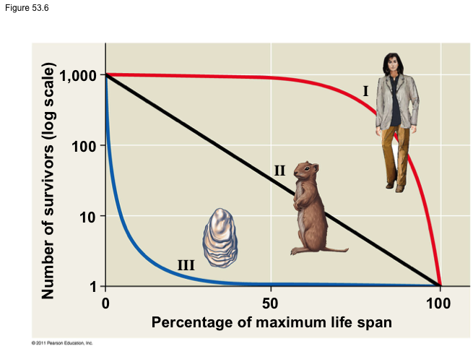

Compare the survivorship curves of type I, II, and III species (Figure 53.6). What do these curves tell you about each species?

**Concept 53.2: The exponential model describes population growth in an idealized, unlimited environment**

Explain what is meant by exponential growth.

Define all variables within the equation for exponential growth below.



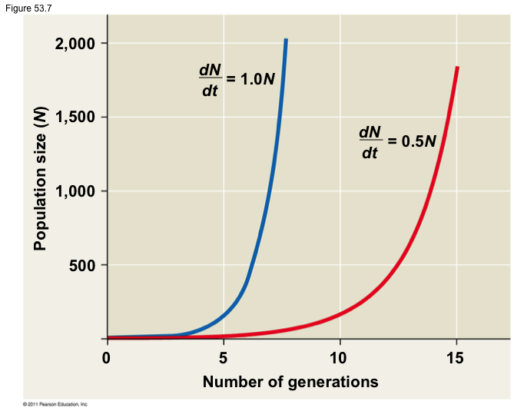

Compare the exponential growth of the two populations displayed in the graph to the right.

Describe an example during which a population might grow exponentially.

**Concept 53.3: The logistic model describes how a population grows more slowly as it nears its carrying capacity**

Explain what is meant by logistic growth and carrying capacity.

Define all variables within the equation for logistic growth below.



Contrast the logistic to the exponential growth curve displayed in the graph to the right.

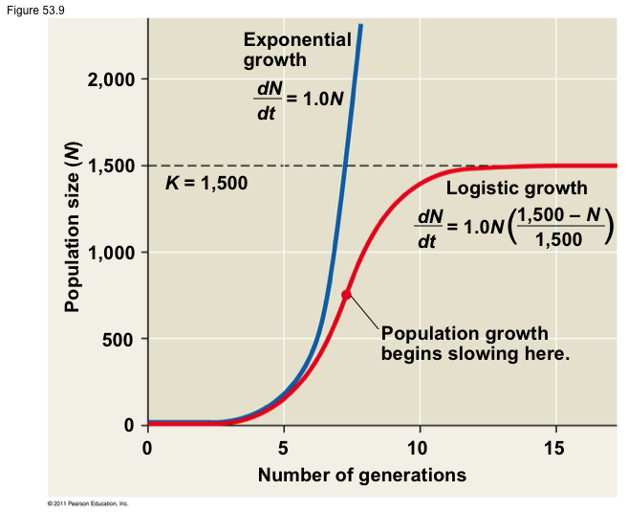

Describe an example during which a population might grow exponentially.

**Concept 53.4: Life history traits are products of natural selection**

The traits that affect an organism’s schedule of reproduction and survival make up its life history. List the three variables that are included.

Differentiate between r-selected and k-selected species. Give an example of each.

**Concept 53.5: Many factors that regulate population growth are density dependent**

*Complete the following table with information about density dependent limiting factors.*

|  |  |  |
| --- | --- | --- |
| Density Dependent Regulation |  | |
| **Type** | **Definition** | **Example** |
| Competition for resources |  |  |
| Territoriality |  |  |
| Disease |  |  |
| Predation |  |  |

Explain how density independent limiting factors impact population growth. Give at least two examples.

**Concept 53.6: The human population is no longer growing exponentially but is still increasing**

Describe how the human population has grown in the past and how that growth has changed over time.

For each of the following age structure diagrams, describe what is shown in terms of the rate of growth in the population.

